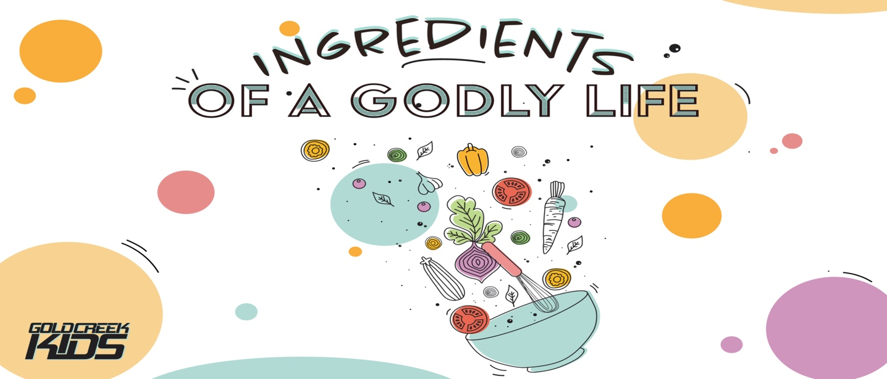

WEEK 4 BIBLE STUDY
*Complete this and bring it to the front door of our Mill Creek campus on MONDAYS from 5:00pm- 5:30pm to drop it off, get the next packet and get a special treat.
(OR take a picture/scan and email to Mariah@goldcreek.org for a special treat delivered to your house)

Memory Verse: “For the Lord grants wisdom! From His mouth come knowledge and understanding.” Proverbs 2:6
Read 1 Kings 3:1-15
Answer these questions:
1.Who was Solomon?

2. What did God offer Solomon?

3. What did Solomon ask for?

4. What did God give Solomon after he made his request?

5. What are some ways we can gain wisdom?

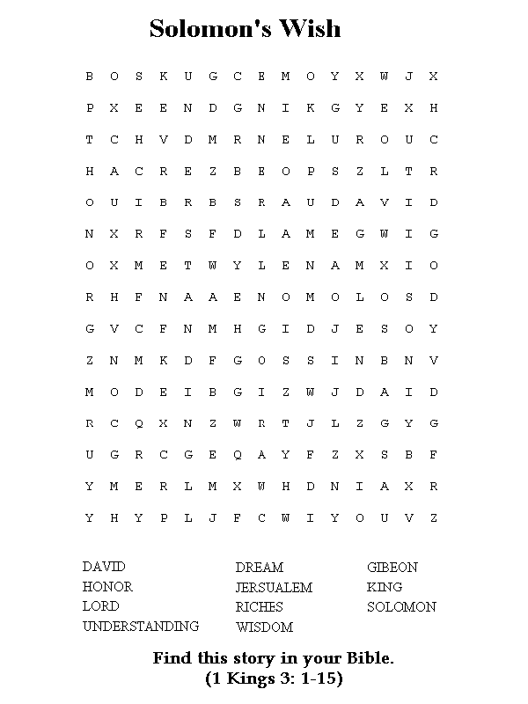
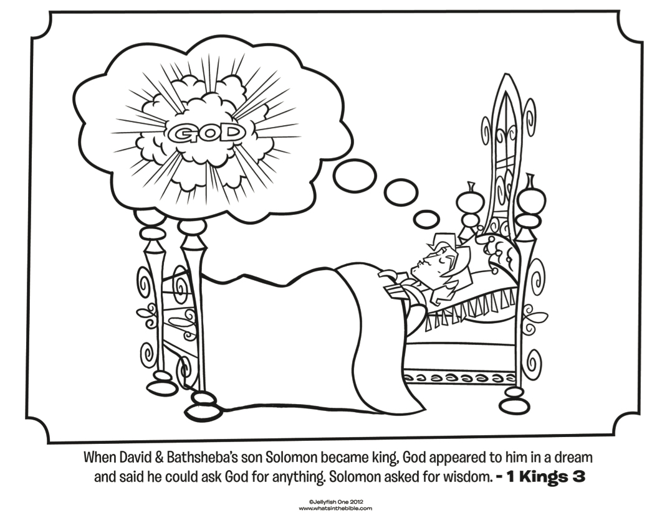MOTHER’S DAY BINGO CARD 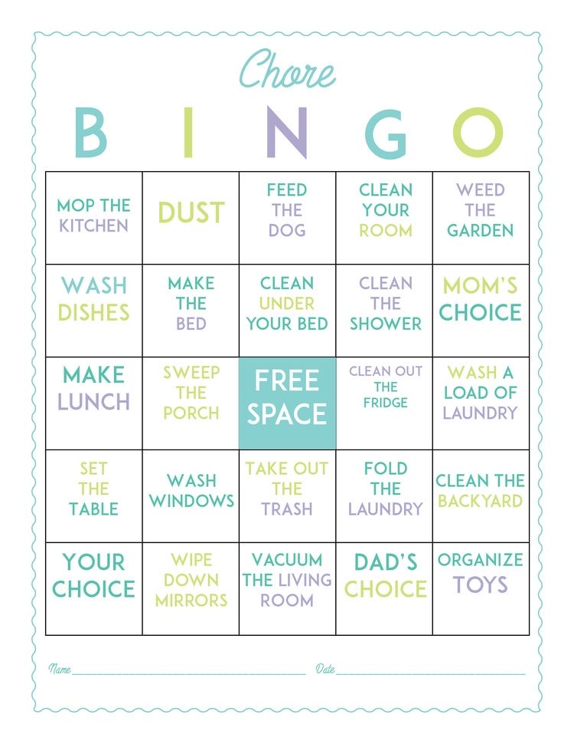
“Complete enough tasks to get a BINGO and turn it in to receive a prize you can enjoy with your mom!”

